Linear Regresstion Problem From Google Colab Into Jupyter NotebooK

**Problem 1 : Sklearn linear Regresstion Problem :**

import numpy as np

import matplotlib.pyplot as plt

import sklearn # This imports the scikit-learn library

np.random.seed(0)

n=20 # Number of data points

x=np.linspace(0, 10, n)

y=x*2 + 1 + 1*np.random.randn(n) # Standard deviation 1

print(x)

print(y)

from sklearn.linear_model import LinearRegression

model=LinearRegression(fit_intercept=True)

model.fit(x[:,np.newaxis], y)

xfit=np.linspace(0,10,100)

yfit=model.predict(xfit[:, np.newaxis])

plt.plot(xfit,yfit, color="black")

plt.plot(x,y, 'o')

# The following will draw as many line segments as there are columns in matrices x and y

plt.plot(np.vstack([x,x]), np.vstack([y, model.predict(x[:, np.newaxis])]), color="red");

[ 0. 0.52631579 1.05263158 1.57894737 2.10526316 2.63157895

3.15789474 3.68421053 4.21052632 4.73684211 5.26315789 5.78947368

6.31578947 6.84210526 7.36842105 7.89473684 8.42105263 8.94736842

9.47368421 10. ]

[ 2.76405235 2.45278879 4.08400114 6.39878794 7.07808431 5.28588001

8.26587789 8.21706384 9.31783378 10.88428271 11.67035936 14.03322088

14.39261667 14.80588554 16.18070534 17.12314801 19.33618434 18.68957858

20.26043612 20.14590426]

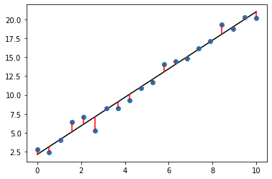

**Problem 2 : linear Regresstion using CSV Data from Colab Environment into Jupyter Notebook:**

**%matplotlib inline**

**from IPython.display import HTML**

**from numpy import \***

**import matplotlib.pyplot as plt**

**import pandas as pd**

**import os**

**variable = pd.read_csv(r"D:\AIMT_INSTALL_SOFTWARE\envs\DataScience_AIML\DatasciencewithAIML\data.csv")**

**variable.head()**

**data = genfromtxt('D:\AIMT_INSTALL_SOFTWARE\envs\DataScience_AIML\DatasciencewithAIML\data.csv', delimiter=',')**

**#Extract columns**

**x = array(data[:,0])**

**y = array(data[:,1])**

**#Plot the dataset**

**plt.scatter(x,y)**

**plt.xlabel('Hours of study')**

**plt.ylabel('Test scores')**

**plt.title('Dataset')**

**plt.show()**

